Before Searching for a movie:

After Searching for a movie:

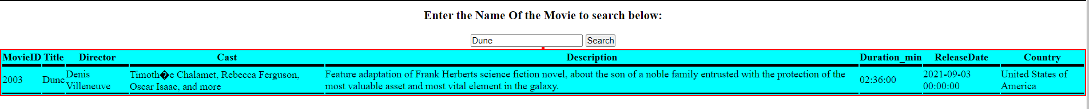

Before Clicking Maximum or Minimum Price

After Clicking Maximum Price:

After Clicking Minimum Price:

